**Task Analysis Grid Task:**

|  |  |  |  |  |  |  |
| --- | --- | --- | --- | --- | --- | --- |
| **Question** | **Remembering** | **Understanding** | **Applying** | **Analysing** | **Evaluating** | **Creating** |
|  |  |  |  |  |  |  |
|  |  |  |  |  |  |  |
|  |  |  |  |  |  |  |
|  |  |  |  |  |  |  |
|  |  |  |  |  |  |  |
|  |  |  |  |  |  |  |
|  |  |  |  |  |  |  |
|  |  |  |  |  |  |  |
|  |  |  |  |  |  |  |
|  |  |  |  |  |  |  |
|  |  |  |  |  |  |  |
|  |  |  |  |  |  |  |
|  |  |  |  |  |  |  |
|  |  |  |  |  |  |  |
|  |  |  |  |  |  |  |
|  |  |  |  |  |  |  |
|  |  |  |  |  |  |  |
|  |  |  |  |  |  |  |
|  |  |  |  |  |  |  |
|  |  |  |  |  |  |  |
|  |  |  |  |  |  |  |

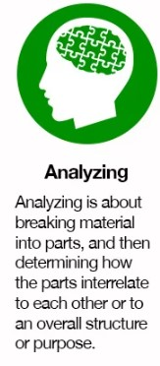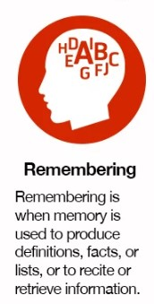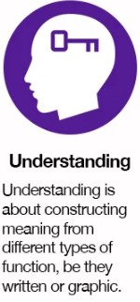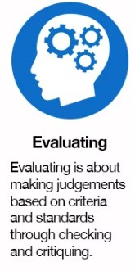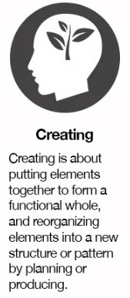

**Task Analysis Grid Task:**

|  |  |  |  |  |  |  |
| --- | --- | --- | --- | --- | --- | --- |
| **Question** | **Remembering** | **Understanding** | **Applying** | **Analysing** | **Evaluating** | **Creating** |
|  |  |  |  |  |  |  |
|  |  |  |  |  |  |  |
|  |  |  |  |  |  |  |
|  |  |  |  |  |  |  |
|  |  |  |  |  |  |  |
|  |  |  |  |  |  |  |
|  |  |  |  |  |  |  |
|  |  |  |  |  |  |  |
|  |  |  |  |  |  |  |
|  |  |  |  |  |  |  |
|  |  |  |  |  |  |  |
|  |  |  |  |  |  |  |
|  |  |  |  |  |  |  |
|  |  |  |  |  |  |  |
|  |  |  |  |  |  |  |
|  |  |  |  |  |  |  |
|  |  |  |  |  |  |  |
|  |  |  |  |  |  |  |
|  |  |  |  |  |  |  |
|  |  |  |  |  |  |  |
|  |  |  |  |  |  |  |



|  |  |
| --- | --- |
| **Recollection:**  Recalling items of information | Recall, identify, recognize, acquire, distinguish, state, define, name, list, label, reproduce, order, indicate,  record, relate, repeat, select, tell, describe, match, locate, report, choose, cite, define, outline, complete,  draw, find, give, isolate, pick, put, show |
| **Comprehension / Interpretation:** Constructing meaning from information | Translate, extrapolate, convert, interpret, abstract, transform, select, indicate, illustrate, represent,  formulate, explain (who/what/when/where/that/how), classify, describe, discuss, express, identify, locate,  paraphrase, recognize, report, restate, review, summarize, find, relate, define, clarify, diagram, outline,  compare, contrast, derive, arrange, estimate, extend, generalize, give examples, ask, distinguish |
| **Application:** Using information in new situations | Apply, sequence, carry out, solve, prepare, operate, generalize, plan, repair, explain, predict, instruct, compute, use, perform, implement, employ, solve, construct, demonstrate, give examples, illustrate, interpret, investigate, practice, measure, operate, adjust, show, report, paint, draw, collect, dramatize, classify, order, change, write, manipulate, modify, organize, produce, schedule, translate, complete, examine, advocate, persuade, resolve |
| **Analysis:** Distilling and/or organising information into its components; solving problems | Analyse, estimate, detect, classify, discover, discriminate, explore, distinguish, catalogue, investigate, break down, order, determine, differentiate, dissect, examine, interpret, calculate, categorize, debate, diagram, experiment, question, solve, test, dissect, deconstruct, focus, find coherence, survey, compare, contrast, classify, investigate, outline, separate, structure, categorize, determine evidence/premises and conclusions, appraise, criticize, debate, illustrate, infer, inspect, inventory, select, deduce, induce, argue, balance, moderate, identify, explain (how/why), challenge, question |
| **Evaluation:** Using standards, criteria, theories, or processes to judge value | Evaluate, argue, verify, assess, test, judge, rank, measure, appraise, select, check, justify, determine,  support, defend, criticize, critique, weigh, assess, choose, compare, contrast, decide, estimate, grade, rate,  revise, score, coordinate, select, choose, debate, deduce, induce, recommend, monitor, compare,  contrast, conclude, discriminate, explain (why), interpret, relate, summarize, challenge, question,  advocate, persuade |
| **Synthesis / Creation:** Relating items of information to each other, integrating them, and generating something new | Write, plan, integrate, formulate, propose, specify, produce, organize, theorize, design, build, systematize,  combine, summarize, restate, discuss, derive, relate, generalize, conclude, produce, arrange, assemble,  collect, compose, construct, create, perform, prepare, propose, strategize, compare, contrast,  hypothesize, invent, discover, present, write, deduce, induce, bring together, pretend, predict, strategize,  modify, improve, set up, adapt, solve, categorize, devise, explain (why), generate, manage, rearrange,  reconstruct, relate, reorganize, revise, argue, extend, project, advocate, persuade, resolve |

**Higher order thinking skills**

Adapted from: Course Design for Constructive Alignment (Winter 2012) Michael K. Potter and Erika Kustra Centre for Teaching and Learning, University of Windsor